**CLASS VII PAPER COMPUTER**

**SECTION A**

**Q1.a Fill in the blanks (2.5)** a. ...**BOOT RECORD**... are the programs that a computer uses to start itself up.b. A ...**MACRO**.... is a set of commands written by the user to be executed later. c. In Visual Basic programming, moving the mouse is an ...**EVENT**. . d. The ...**TITLE**.... at the top of the Visual Basic window displays the title of the project. e. ..**INSTANT MESSAGING**....... is a communication service that allows instant transmission of text-based messages from the sender to the receiver.

**Q1 b. Write T for the true statement and F for the false one:(2.5)**

a. You should first read the spam mails and then delete them. .**FALSE**

b. A virus can infect both the software and the hardware of a computer. ........... **FALSE**................ c. Method is an action that can be performed on a control. .**TRUE**....... d. Two or more strings cannot be added one after the other. .... **FALSE**....................... e. Twitter was founded by Mark Zuckerberg. ........... **FALSE**..............

**Q1 c Give three facts about the following:(2.5)**

1. **Variable naming rules**

a. • Variable names must have less than 255 characters.

• They should not contain spaces or periods.

• They must not start with a digit.

**Visual Basic Programming** • VB uses a GUI interface. • It is event-driven.

• It is based on the BASIC programming language

Q1d. (2.5)

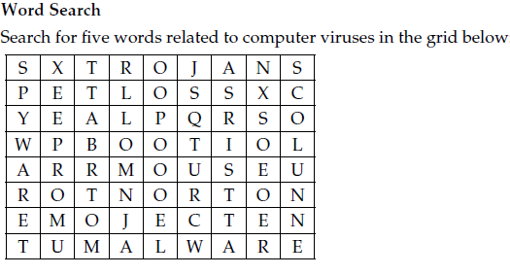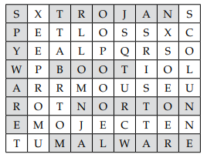

**SECTION B ( SHORT QUESTION ANSWER any 6 and part (a) is compulsory) (25)**

a. What are feed readers?

**Macro virus** b.How does a computer virus spread from one computer to another ?

**Computer viruses spread from one computer to another by the transfer of infected data through emails, pen drives, or other sources.**

c.What is an assignment statement ?Explain with example.

**After declaring a variable using the Dim statement, one can assign a value to it using an assignment statement. The general format of an assignment statement is: Variable = Expression or Constant For example: A = 100 or A = B * C**

d.List all arithmetic operators used in visual basics ?

**The arithmetic operators used in Visual Basic are: Addition (+), Subtraction (-), Multiplication (*), Exponent (^), Division (/), Integer Division (\), and Modulus (Mod).**

e.Name any two online games .? f. Name the type of virus that infects data files ? g.Mention any two things that you should not do while chatting.?

**SECTION C ( LONG QUESTION ANSWER any 3 ) (15)**

a.Define computer virus.How can it harm your computer.

**A computer virus is a software program that has the ability to make copies of itself, and to attach itself to other programs or files. Different viruses do different things. A computer virus could be capable of any of the following:**

**• It can infect executable program files such as word processors, spreadsheets, and operating systems.**

**• It can infect disks by attaching itself to special programs on the hard disk, called boot records. These are the programs that the computer uses to start itself up.**

**• It can infect files that are attached to email messages or copied to disks and pen drives. In this manner, it can spread from one computer to another.**

b. What is the output of the following. a.( 16/3) b.(16\3) c.(16 mod 3) d.5^3

**i. 5.333 ii. 5 iii. 1 iv. 125**

**c.Analyze the how boot , macro , and program viruses affect the working of the computer?**

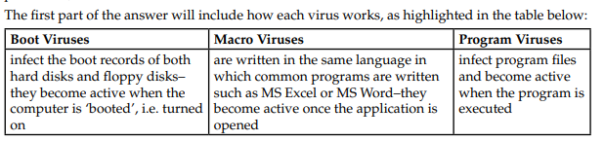d.Name any four components of the visual basic IDE screen and their uses?

e.What are two ways of placing controls on a form?

**The two methods of placing controls on a form are given below: First Method:**

1. **Double-click on the control in the Toolbox. Here the control chosen is a button. By default, buttons are named Button1, Button2, etc.**
2. **The control appears at the top-left corner of the form. To change the position of the control, click on it, hold down the left mouse button, and drag it to the new location iii. To resize the control, drag the resize pointers on its edges or corners. iv. Drag the edges pointer for changing the size either horizontally or vertically. v. Drag the corner pointers for changing the size diagonally.**

**Second Method:**

1. **Click on the control in the Toolbox, and with the left mouse button pressed down, drag and drop it onto the form.**

**ii. Reposition the control by holding down the left mouse button and dragging it to a new location. To resize the control, drag one of its edges or corners.**  f.What is use of Picasa?